COURSE TITLE | REQUIRED TEXT
EDUC 5034: Diverse Learners & Ed. Psych | 1. Siefert, K and Sutton, R. (2009). Educational Psychology, 2nd Edition. The Saylor Foundation. https://www.saylor.org/site/wp-content/uploads/2012/06/Educational-Psychology.pdf  Links to an external site.  2. OPTIONAL TEXT FOR 7 WEEK SECTION:  Willingham, D. T. (2009). Why don't students like school?: A cognitive scientist answers questions about how the mind works and what it means for the classroom. John Wiley & Sons. https://moodrmoo.files.wordpress.com/2014/10/why-dont-students-like-school.pdf  Links to an external site.
EDUC 5120: Creating and Managing a Learning Environment | Required: Alberto, P.A., & Troutman, A.C. (2013). Applied behavior analysis for teachers (9th ed.). Upper Saddle River, NJ: Prentice Hall. ISBN# 0132655977.  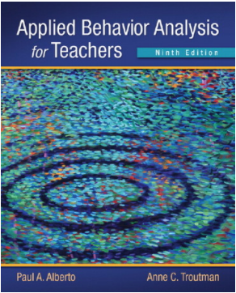
EDUC 5160: Curriculum, Tech & Assessment | No text required
ELED 5460: Methods of Language Arts | Muschla, Gary, Muschla, Judith, Muschla, Erin. (2010). The Elementary Teacher’s Book of Lists. Jossey-Bass Teacher. ISBN: 978-0-470-50198-6.
ELED 5470: Methods of Teaching Math | Muschia, Gary Robert, Muschla, Judith, Muschla, Erin (2016). The Elementary Teacher’s Book of Lists (1st Ed.) Jossey-Bass A Wiley Imprint, San Francisco, CA, ISBN: 978-0-470-50198-6
ELED (EDPD) 5485 :Methods of Social Studies | No text required
ELED (EDPD) 5495: Methods of Teaching Science, Health, & PE | Textbook: (Recommended, but not required)  Muschia, Gary Robert, Muschla, Judith, Muschla, Erin (2016). The Elementary Teacher’s Book of Lists (1st Ed.) Jossey-Bass A Wiley Imprint, San Francisco CA, 978-0-470-50198-6  Resources:  NGSS (Next Generation Science Standards) Reston, Virginia  Utah State Board of Education Core Curriculum/Science, Science and Engineering Education Standards (SEEdS)  Utah State Board of Education Core Curriculum/Health, Healthy Lifestyle and Physical Education Standards
SCED 5720: Literacy in Content Areas | Students will be expected to plan and conduct a few investigations. These can be done with common household materials. If you do not have materials for an investigation, please reach out and we can make other arrangements.
SPED 5030: Introduction to Special Education | Gargiulo, R. M., & Metcalf, D. J. (2017). Teaching in today's inclusive classrooms: A universal design for learning approach (3rd ed.). Boston, MA: Cengage Learning. [ISBN: 978-1305500990]  eText Link: https://www.cengage.com/c/teaching-in-today-s-inclusive-classrooms-a-universal-design-for-learning-approach-3e-gargiulo/9781305500990/
SPED 5100: Program Management and M/M Disabilities | Yell, M.L., Bateman, D.F., & Shriner, J.G. (2022). Developing Educationally Meaningful and Legally Sound IEPs.  ISBN-13: 978-1538138014  ISBN-10: 1538138018
SPED 5110: Special Education Law | Markelz, A.M. & Bateman, D.F. (2022). The Essentials of Special Education Law. ISBN: 978158150030
SPED 5120: Applied Behavior Analysis for Teachers | Required: Alberto, P.A., & Troutman, A.C. (2013). Applied behavior analysis for teachers (9th ed.). Upper Saddle River, NJ: Prentice Hall. ISBN# 0132655977.
SPED 5145: Transition and Collaboration | Friend, M. & Cook, L. (2017). Interactions: Collaboration Skills for School Professionals, 8th Ed. Pearson. ISBN-13: 978-0-13-425680-1
SPED 5160: Assessment & Decisions | No text required. Course materials are linked in the MODULE OVERVIEW tab each week.
SPED 5170: Intervention Strategies in Math | 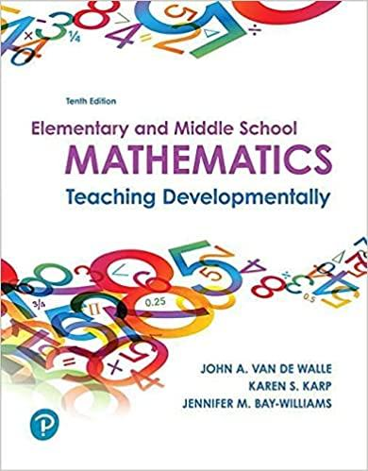  Elementary and Middle School Mathematics: Teaching Developmentally  10th Edition by John Van de Walle  Links to an external site.(Author), Karen Karp Links to an external site.(Author), Jennifer Bay-Williams  Links to an external site.(Author)  Publisher‏: ‎ Pearson; 10th edition (January 23, 2018)  Language: ‎ English  Paperback: ‎ 720 pages  ISBN-10: ‎ 013480208X  ISBN-13: ‎ 978-0134802084  We will also complete the National Center on Intensive Intervention  Links to an external site. course focused on mathematics intervention. https://intensiveintervention.org/  Links to an external site.  When you click on the link it looks like this:  Intensive intervention site-1.png  Principles for Designing Intervention in Mathematics (Links to PDF)  Links to an external site.This is only 16 pages, but covers basic principles of designing intervention that should be applied beyond the examples provided in this text  Intensive Intervention in Mathematics  CASE STUDIES FOR THIS COURSE COME FROM THE FOLLOWING LINK:  Mathematics: Identifying and Addressing Student Errors  Links to an external site.  You can download this and keep it for future reference as well  CEC High Leverage Practices in Special Education  Links to an external site.  You can download this to keep for future reference  The following text book carries over from the 5130 curriculum strategies in ELA course. It is helpful, but is not required. I suggest keeping it as a resource  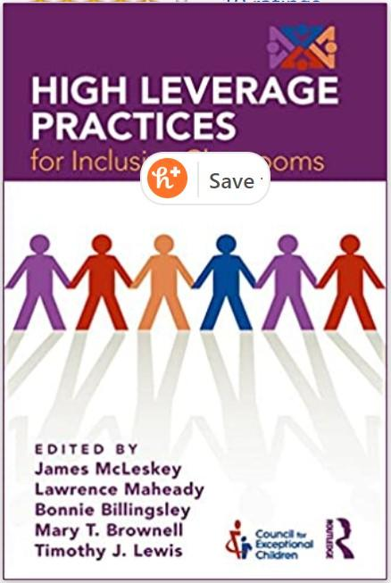  High Leverage Practices for Inclusive Classrooms  By: James McLeskey  Publisher: Routledge  Print ISBN: 9781138039193, 1138039195  eText ISBN: 9781351708715, 1351708716  Edition: 1st  Copyright year: 2019

