March 30, 2018

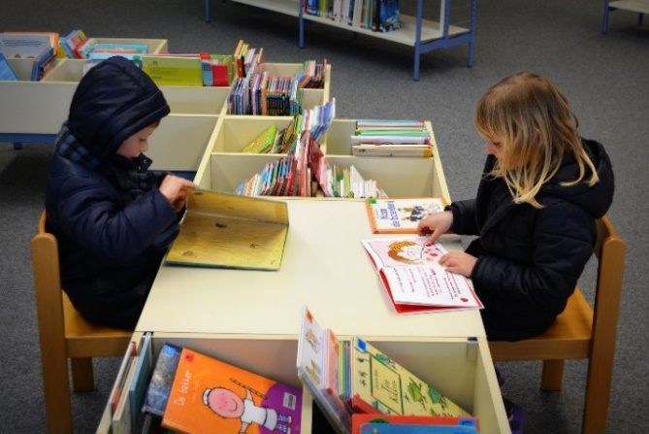

Reports
Library Newsletter
Tip Top Elementary
This section of your newsletter can be dedicated to reporting on library activities that have already taken place, statistics about circulation, or topics requested by administrators or parents.
When you regularly report on the success of library events or any needs that arise in the school library, you are more likely to receive the support you need from administrators, teachers, and parents. This is also a place for you to showcase any awesome initiatives you have started and follow up with stakeholders.
Mrs. Librarian is currently reading…

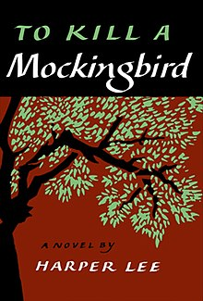

Upcoming Events
- List upcoming events and activities that will be taking place in the school library.
- You may also want to list times that the library will be closed or times the library will be open extra hours.
- It might be a good idea to list student work that will be on display during the month.
- Or you could mention upcoming awareness events like National Library Month, Earth Day, and many others, even if you don’t plan to do any activities or displays connected to the events.
- When you mention events, make sure that readers will know the dates they will take place and how they can participate.
- If you need donations, this section would also be a good place to mention that donations of volunteer time or supplies to help put on an event would be useful.
Reminders about Library Policies and Procedures
- Kindergarten and first grade students may check out one book at a time.
- Second and third grade students may check out two books at a time.
- Fourth, fifth, and sixth grade students may check out three books at a time.
Consider using this section as a way to highlight policies and procedures so that your stakeholders know what to expect in the school library. You might also explain why you have these policies.

Fun Fact about Mrs. Librarian
Consider sharing something about yourself so that your stakeholders can get to know you. Be professional with what you choose to share about yourself. The idea of a fun fact section would be to build trust!

Library Vision
A regular part of your newsletter could be a statement of your library vision, mission, or philosophy.

Student/Teacher Review
This sort of section can be used in several different ways. You could get quotes from students or teachers about the school library. These quotes could be about events, class activities, collaboration, or even a book that the student or teacher has recently read and would like to review.
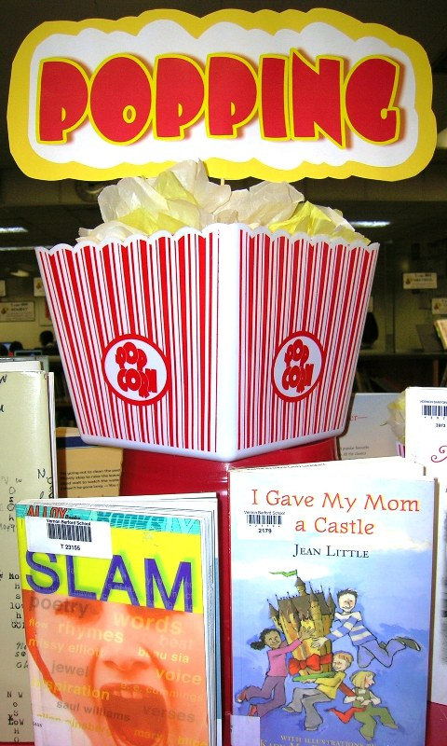
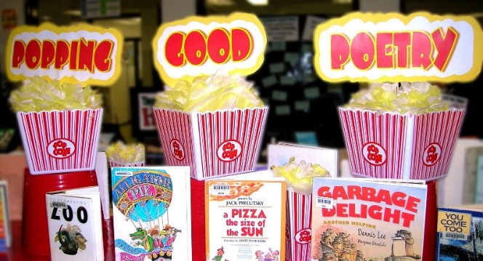
Another way you might use a section like this in your newsletter would be to highlight teachers who have collaborated with you and let them voice their experience on the project, or get student input about the collaboration. Or you could highlight contributions from volunteers, whether they be adults or children. This might be one way that you recognize their efforts.
“Popping Good Poetry” by Enockson is licensed under Creative Commons BY-NC-SA 2.0.

About Displays, Monthly Themes, New Acquisitions, or Big Events
This is a section that can be used to discuss why the school library is celebrating National Poetry Month or whatever else your events and displays might be.
You could choose to give a history of the event, discuss the display, explain the activites that will be done in connection with the display, and so on. You might also do a more detailed report about how a display was received. Including pictures from the event or of the display will spark interest in your stakeholders. You might also highlight new library acquistions that will catch the attention of stakeholders.
This entire newsletter is intended to be customizable so that you can either use it as a template and change the colors, pictures, and details to meet the needs of your library, OR simply to give you ideas about how to organize a newsletter of your own, inspire new content, and spark realizations about what can be accomplished with an effective newsletter.
We hope that you will modify what you see to fit the needs of your learning community.
Curriculum Connection

This final section is where we hope you will show off how you are tying core curriculum subjects and AASL standards into regular curriculum activities. You can discuss how it went the last month or announce which standards you will be addressing in the month to come. This will help stakeholders see your expertise and commitment to learning. LAB hopes this section will showcase how the school library supports students and teachers.

